**Practical 11**

**import tensorflow as tf**

**from tensorflow.keras import datasets, layers, models**

**import matplotlib.pyplot as plt**

**# Load and preprocess the CIFAR10 dataset**

**(train_images, train_labels), (test_images, test_labels) = datasets.cifar10.load_data()**

**train_images, test_images = train_images / 255.0, test_images / 255.0**

**# Define the CNN model**

**model = models.Sequential()**

**model.add(layers.Conv2D(32, (3, 3), activation='relu', input_shape=(32, 32, 3)))**

**model.add(layers.MaxPooling2D((2, 2)))**

**model.add(layers.Conv2D(64, (3, 3), activation='relu'))**

**model.add(layers.MaxPooling2D((2, 2)))**

**model.add(layers.Conv2D(64, (3, 3), activation='relu'))**

**model.add(layers.Flatten())**

**model.add(layers.Dense(64, activation='relu'))**

**model.add(layers.Dense(10))**

**# Compile the model**

**model.compile(optimizer='adam',**

**loss=tf.keras.losses.SparseCategoricalCrossentropy(from_logits=True),**

**metrics=['accuracy'])**

**# Train the model**

**history = model.fit(train_images, train_labels, epochs=10,**

**validation_data=(test_images, test_labels))**

**# Evaluate the model**

**test_loss, test_acc = model.evaluate(test_images,  test_labels, verbose=2)**

**print(f"Test accuracy: {test_acc}")**

**# Plot training history (optional)**

**plt.plot(history.history['accuracy'], label='accuracy')**

**plt.plot(history.history['val_accuracy'], label = 'val_accuracy')**

**plt.xlabel('Epoch')**

**plt.ylabel('Accuracy')**

**plt.ylim([0.5, 1])**

**plt.legend(loc='lower right')**

**plt.show()**

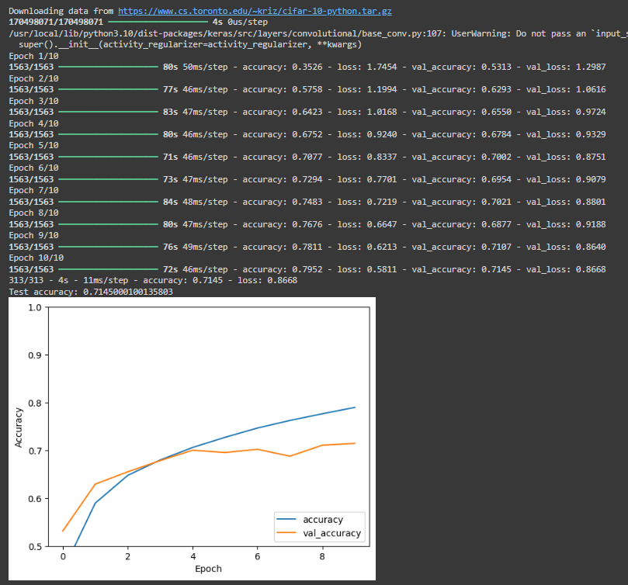

**Object detection using CNN**

**import tensorflow as tf**

**import numpy as np**

**import cv2**

**from tensorflow.keras.losses import mse**

**# Load the saved model**

**model = tf.keras.models.load_model('my_cifar10_model.h5', custom_objects={'mse': mse})**

**# Define class names for CIFAR-10**

**class_names = ['airplane', 'automobile', 'bird', 'cat', 'deer',**

**'dog', 'frog', 'horse', 'ship', 'truck']**

**# Display the uploaded image**

**plt.imshow(img)**

**plt.axis('off')**

**plt.show()**

**# Load and preprocess an image (replace with your own image)**

**img_path = '/content/download.jpg'  # Replace with the path to your image**

**img = cv2.imread(img_path)**

**img = cv2.cvtColor(img, cv2.COLOR_BGR2RGB)**

**img = cv2.resize(img, (32, 32))  # Resize to CIFAR-10 input size**

**img = img / 255.0  # Normalize**

**# Make a prediction**

**img_array = np.expand_dims(img, axis=0)**

**predictions = model.predict(img_array)**

**predicted_class = np.argmax(predictions[0])**

**# Display the result**

**print(f"Predicted class: {class_names[predicted_class]}")**

